**National University of Computer and Emerging Science**

**Assignment No: 1**

**Subject: Object Oriented Analysis and Design.**

**Submitted to: Asst. Prof. Engr Abdul Rahman Mahmood.**

**Name: Muhammad Mustafa Manga.**

**Roll no.: 17k-3795.**

**Date of Submission:19-Sep-2019**

**Section: E.**

**Department: Computer Science.**

**Description of Use Case:**

**1)**

**Use Case:** Enroll Department.

**Actor:** Professor(initiator).

**Type:** Primary.

**Description:** Professor is enrolled in one department.

**2)**

**Use Case:** Book Appointment.

**Actor:** Patient(initiator).

**Type:** Primary.

**Description:** Patient book an appointment.

**3)**

**Use Case:** Visit Patient

**Actor:** Doctor (initiator).

**Type:** Primary.

**Description:** Doctor visit patient.

**4)**

**Use Case:** Schedule Appointment.

**Actor:** Receptionist (initiator).

**Type:** Primary.

**Description:** Receptionist Schedule the appointment.

**5)**

**Use Case:** Deliver Medicine.

**Actor:** Pharmacy (initiator).

**Type:** Secondary.

**Description:** Pharmacy deliver medicine to inpatient only over the phone request and customer and outpatient from window

**6)**

**Use Case:** Receive Medicine.

**Actor:** Patient.

**Type:** Secondary.

**Description:** Customer/Patient receive medicine form pharmacy.

**7)**

**Use Case:** Service in Emergency Department.

**Actor:** Specialist / Consultant.

**Type:** Primary.

**Description:** Service deliver by consultant and specialist in emergency department.

**Models:**

**Q1:**

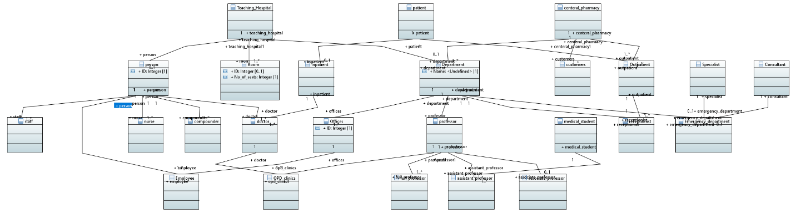

**Q2:**

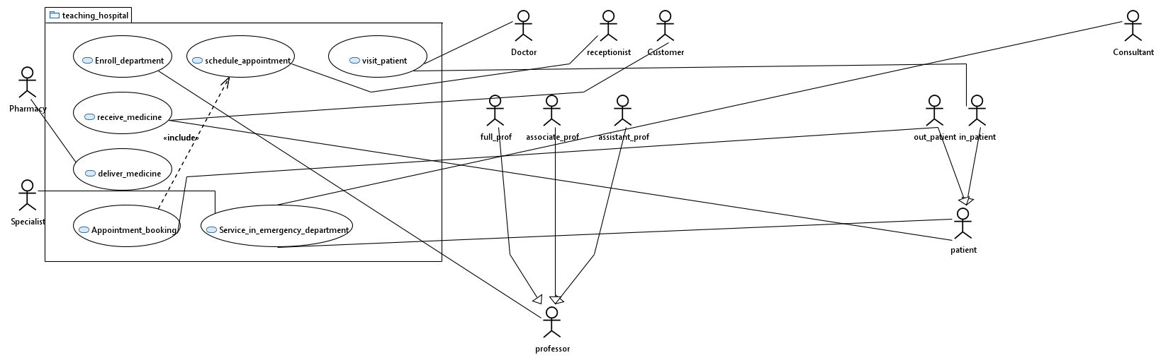

**Q3:**

